Title
I. Israeli¹, S. Sample ^{2,3} and D. Domy¹
¹Department of Xxxxxx, Xxxxx University, City, Israel
²Deptartment of Xxxxxx, Xxxxx University, City, Israel
³The Xxxx Center, The Xxxx City, Israel

Font Time New Roman, 12pt , reference [1] or [1,2]

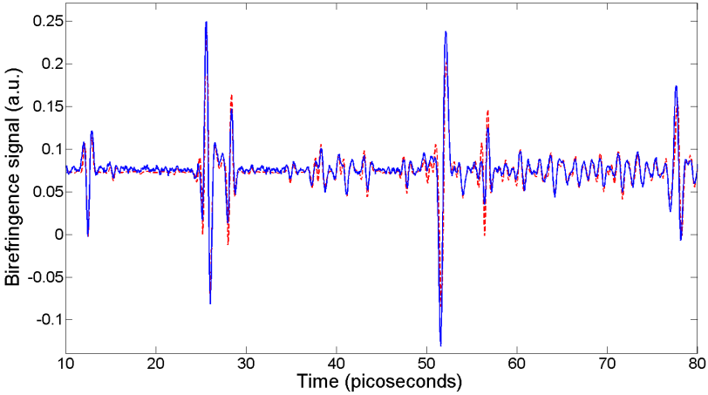
Fig. 1: Font Time New Roman, 12pt.

[1] D. Gelman and R. Kosloff, Chem. Phys. Lett., 381, 129 (2003).
[2] S. Kallush, and S. Fleischer, Phys. Rev. A, 91, 063420 (2015).

